**Manual of code**

**Lab 6.1**

**Explanation of the Code**

This code implements a Breadth-First Search (BFS) algorithm to traverse a graph. BFS is a method for exploring a graph level by level, starting from a given node. The code uses a list to simulate the behavior of a queue (First-In-First-Out or FIFO) to keep track of nodes to visit next.

**How the Code Works**

1. The bfs_without_queue Function

The bfs_without_queue function performs the Breadth-First Search. It takes two inputs:

* graph: A list of lists representing the graph. Each index in the outer list corresponds to a node, and the inner list contains its neighboring nodes.
* start: The starting node for the traversal.



**2. Data Structures Used**

* visited: A list of boolean values to keep track of nodes that have already been visited. This ensures that each node is processed only once.
* node_visit: A list that acts as a queue (First-In-First-Out or FIFO) to store nodes that need to be visited.



**3. Traversing the Graph**

The algorithm works as follows:

1. Start by marking the start node as visited and adding it to the node_visit list.
2. While the node_visit list is not empty:
   * Remove the first node from the list (this simulates the FIFO behavior of a queue).
   * Print the node (or process it in some way).
   * Add its unvisited neighbors to the end of the node_visit list and mark them as visited.

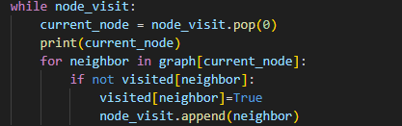

4. The Graph

The graph is represented as a list of lists. Each index in the outer list corresponds to a node, and the inner list contains its neighboring nodes. Here's the graph used in the code:

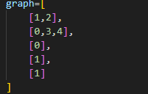

5. Running the BFS

The BFS is started from node 0:



Step-by-Step Execution

Here’s what happens when the BFS is run:

1. Start at node 0:
   * Mark 0 as visited.
   * Add 0 to the node_visit list.
2. Process node 0:
   * Print 0.
   * Add its neighbors 1 and 2 to the node_visit list.
3. Process node 1:
   * Print 1.
   * Add its neighbors 3 and 4 to the node_visit list.
4. Process node 2:
   * Print 2.
   * Node 2 has no unvisited neighbors.
5. Process node 3:
   * Print 3.
   * Node 3 has no unvisited neighbors.
6. Process node 4:
   * Print 4.
   * Node 4 has no unvisited neighbors.

Output

The output of the BFS traversal starting from node 0 is:

